NAME: Madireddy Mahesh

Batch: March 1st 2022

Tutor: Raham Shaik

Project Name: Code & Artifactory

**NEXUS ARTIFACTORY ON UBUNTU:**

* As a Prerequisite installed the vim package and java package
* Went to the cd/opt directory and Fetched the Nexus download link <https://download.sonatype.com/nexus/3/nexus-3.39.0-01-unix.tar.gz> from the internet.
* Untar the nexus-3.39.0-01-unix.tar.gz file by running the ( tar -zxvf nexus-3.39.0-01-unix.tar.gz ) command
* Rename the nexus-3.39.0-01 to nexus by running the ( mv /opt/ nexus-3.39.0-01 /opt/nexus ) command.
* Added nexus user by running the ( adduser nexus ) command.
* Given Root Privileges to nexus user by running the ( visudo ) command.
* Changed the ownership of the nexus by running the (chown -R nexus:nexus /opt/nexus and chown -R nexus:nexus /opt/sonatype-work ) commands.
* Ran the vim /opt/nexus/bin/nexus.rc and nexus to run as a user.
* To check the memory allocation ran the ( vim /opt/nexus/bin/nexus.vmoptions ) command and checked the memory allocation.
* Wrote the simple script to launch the nexus repos by running the ( vim /etc/system/system/nexus.service ) command.

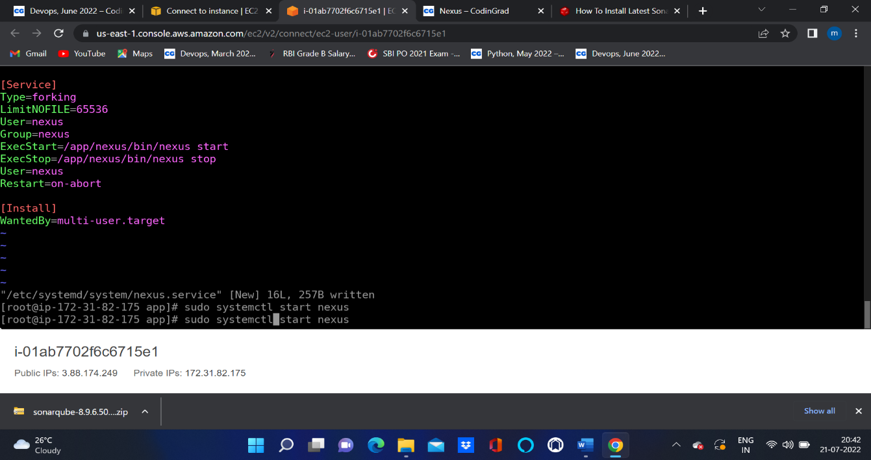

* Started the nexus services by running the ( systemctl start nexus ) command.
* Enabled the nexus service by running the ( systemctl enable nexus ) command.
* Checked the nexus service status by running the ( systemctl status nexus ) command.

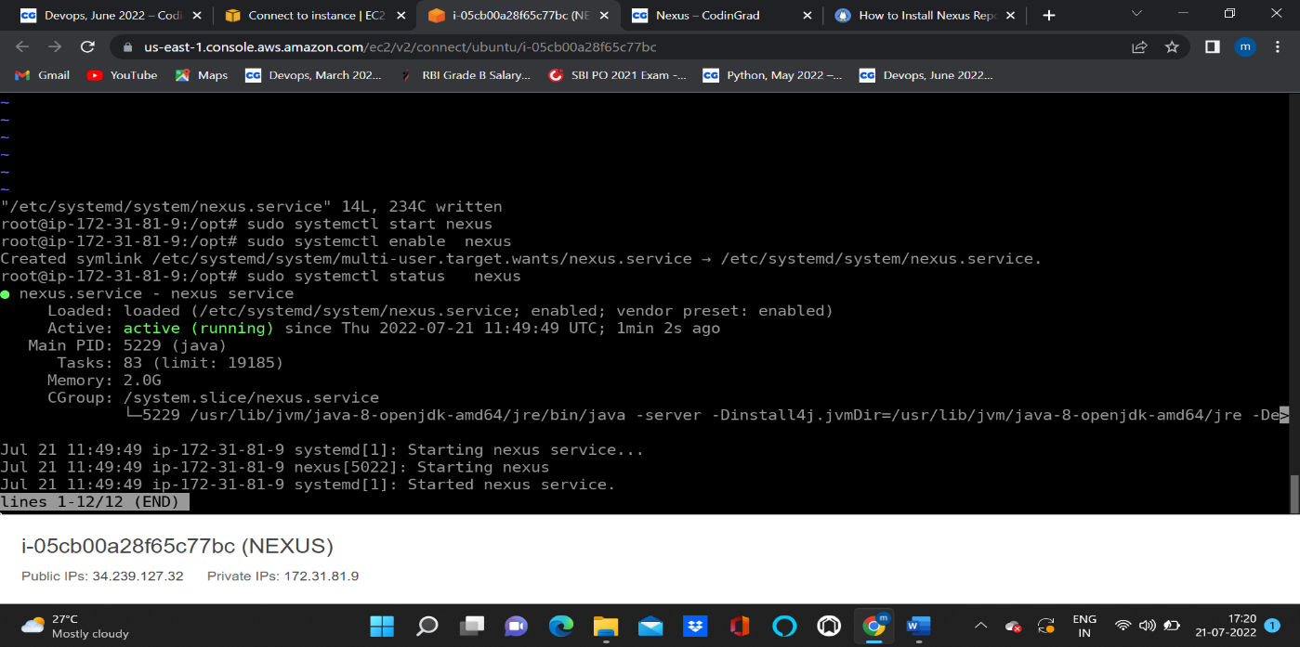

* Taken the Public IP address and log into the web console with port 8081.
* Successfully launched the nexus artifact.

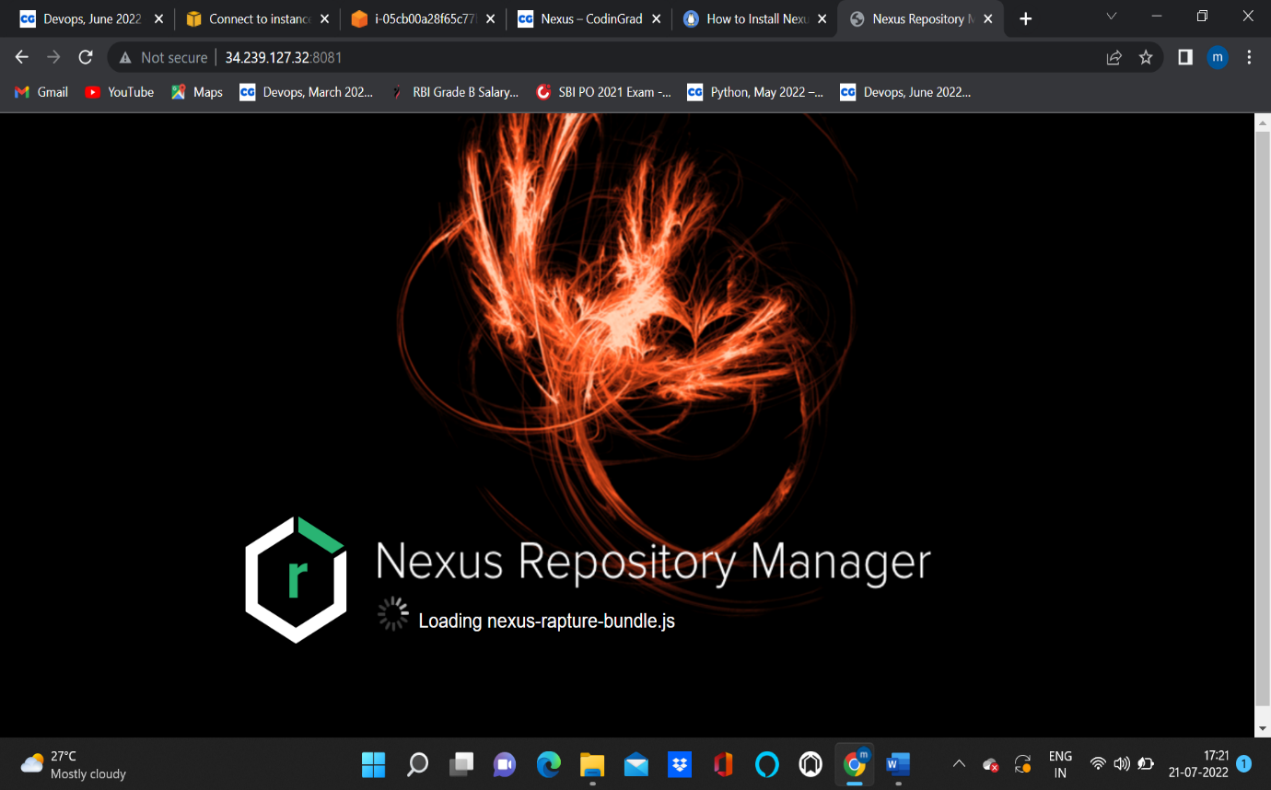

* Nexus Dashboard will open

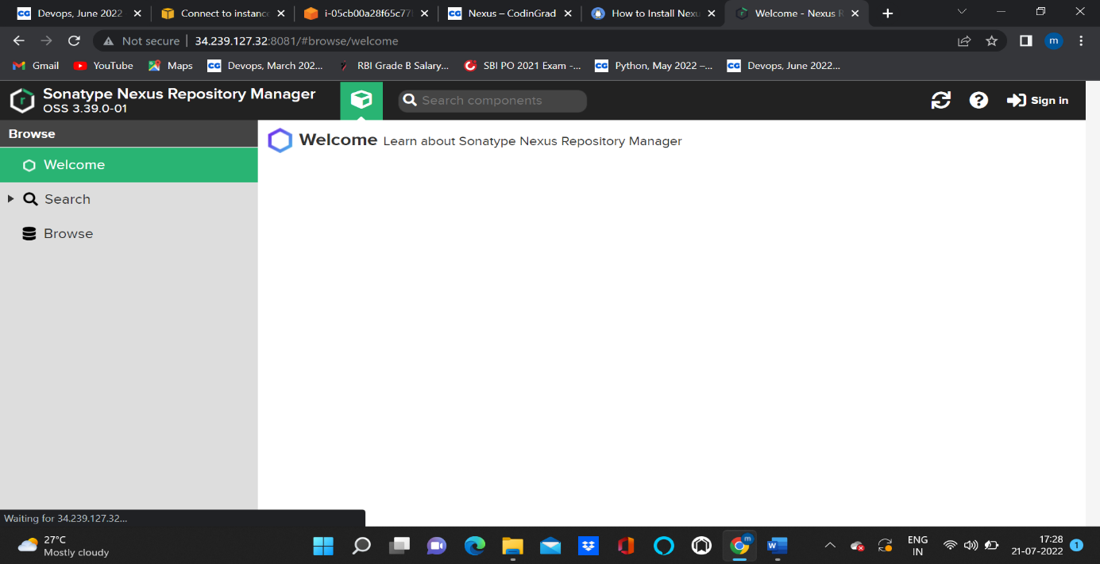

* After login to the account

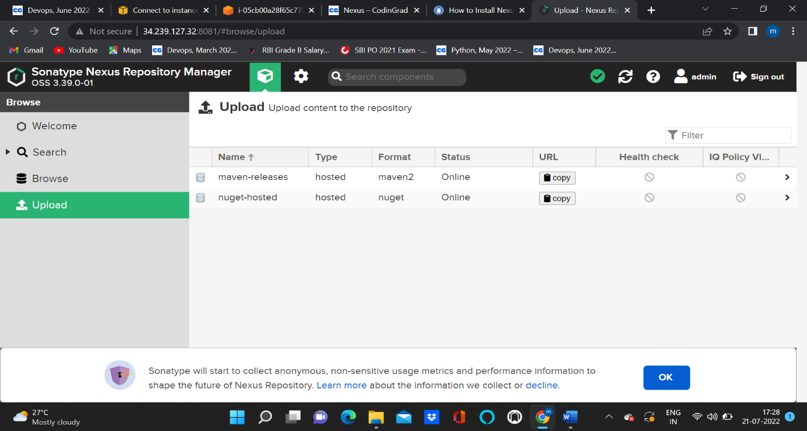

**JFROG INSTALLATION ON AMAZON INSTANCE:**

* Fetch the resource from the internet by running wget -O jfrog-artifactory-pro.tar.gz "https://releases.jfrog.io/artifactory/artifactory-pro/org/artifactory/pro/jfrog-artifactory-pro/[RELEASE]/jfrog-artifactory-pro-[RELEASE]-linux.tar.gz"
* Untar the Tar file by running ( tar -zxvf artifactory-pro-7.38.10 ) command .
* Went to bin directory and started artifactory by running the ( ./artifactoryctl start ) command.
* Checked artifactory status by running the ( ./artifactoryctl start ) command.
* Add the ports 8081 and 8082 to firewall exceptions:

* + - sudo firewall-cmd --permanent --zone=public --add-port=8081/tcp
    - sudo firewall-cmd --permanent --zone=public --add-port=8082/tcp
    - sudo firewall-cmd –reload
* Taken the Public IP address and accessed the JFROG with port number 8082.

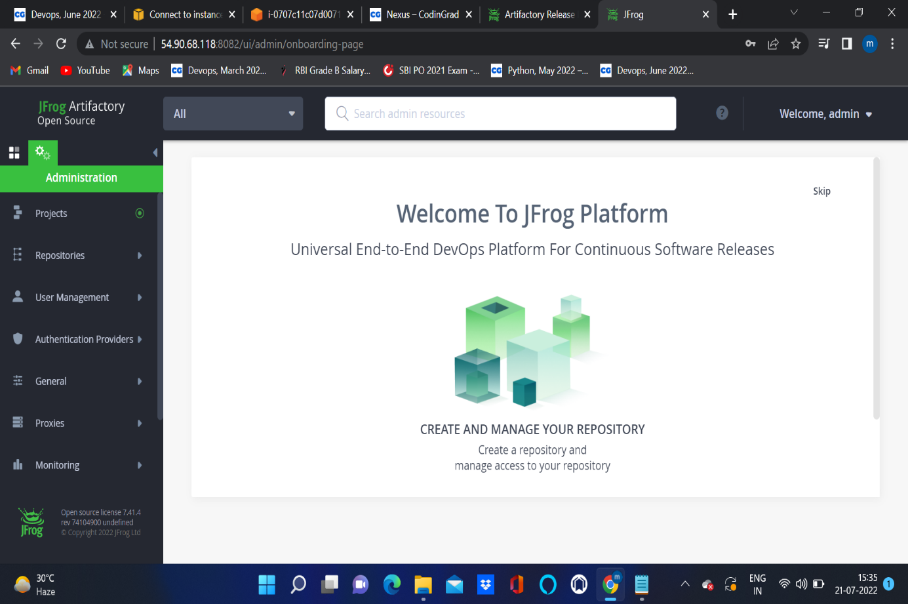

* Login as admin

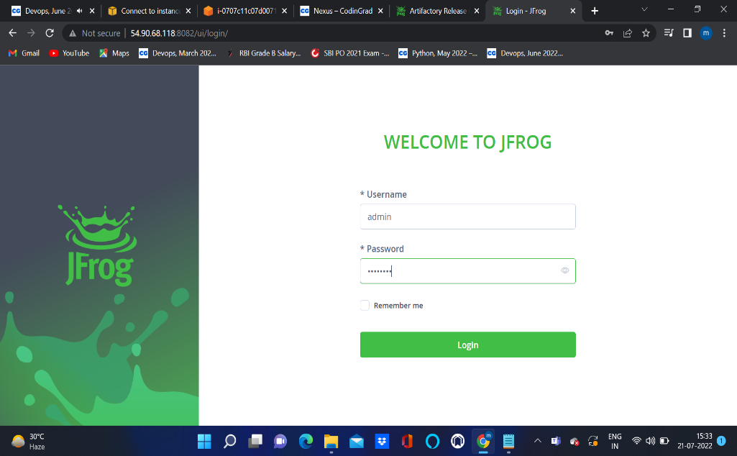

* After login with default credentials
* We can change username and password

